THE STOLEN SZECHAUN SAUCE
DFIR ASSIGNMENT CASE-001

CREATED BY:
SHAWN PERREAULT
FOR:
LIGHTHOUSE LABS
WEEK 10

TABLE OF CONTENTS

Introduction__________________________________________________________________1

Server OS____________________________________________________________________1

Server local Time And IP________________________________________________________2

Windows 10 Workstation________________________________________________________3

Auto-run files_________________________________________________________________4

Packet Captures______________________________________________________________5-6

Virus Total___________________________________________________________________7

File Hash_____________________________________________________________________8

Secret File____________________________________________________________________9

Conclusion____________________________________________________________________9

Introduction:

For this assignment we will be analyzing the CASE-001 and CASE-002 files , The Stolen Szechaun sauce. We will be using FTK imager, Registry Ripper and Autopsy as our tools for our analysis. It is an important practice to work off a copy of the disk image to ensure that you do not change or alter the data as it could never be recovered and may be needed as evidence.

Questions to Answer / Goals
- What’s the Operating System of the Server? Windows server 2012

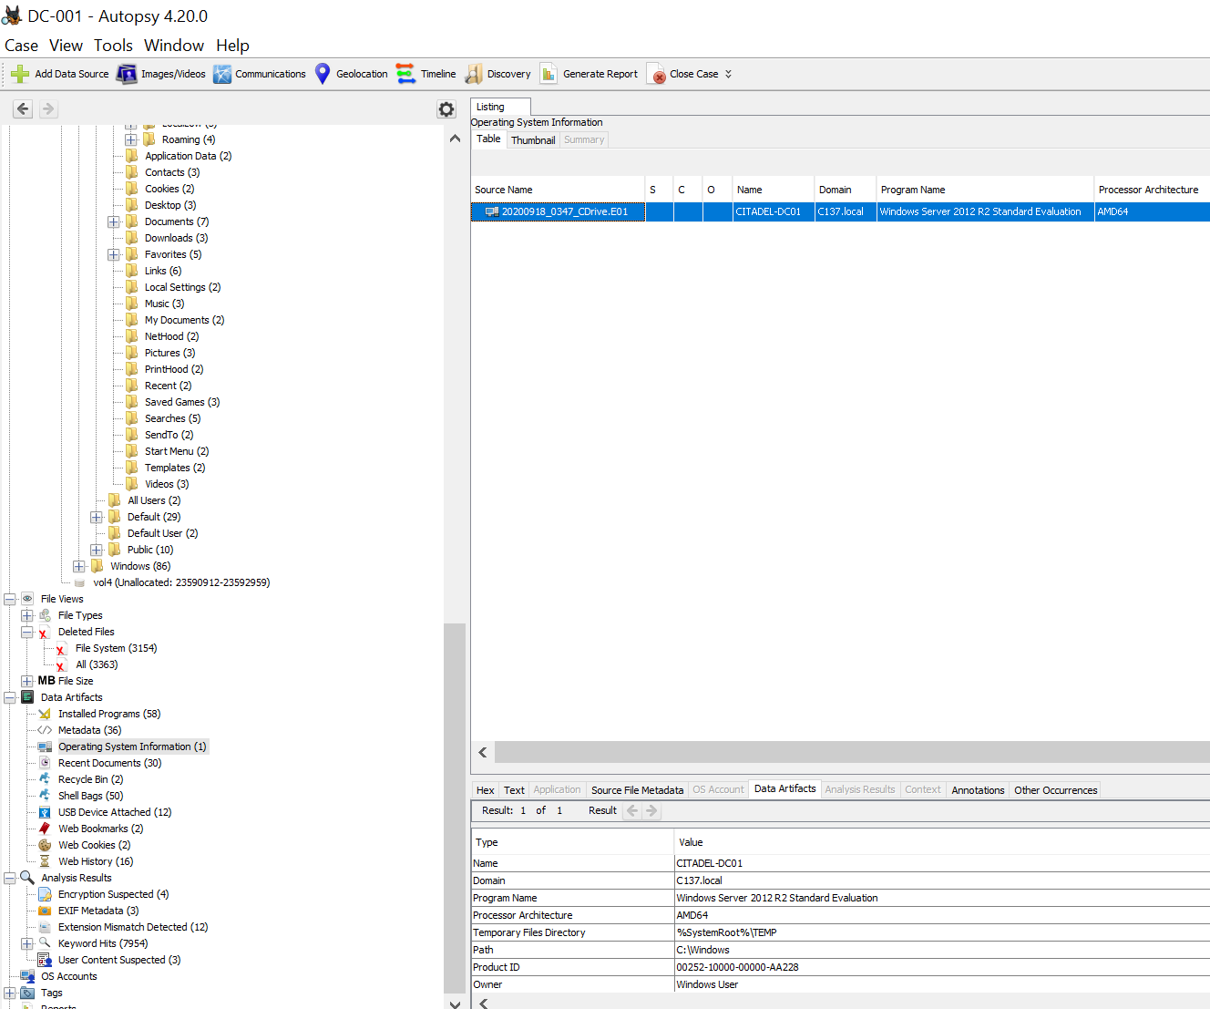

1
- What was the servers Local time?

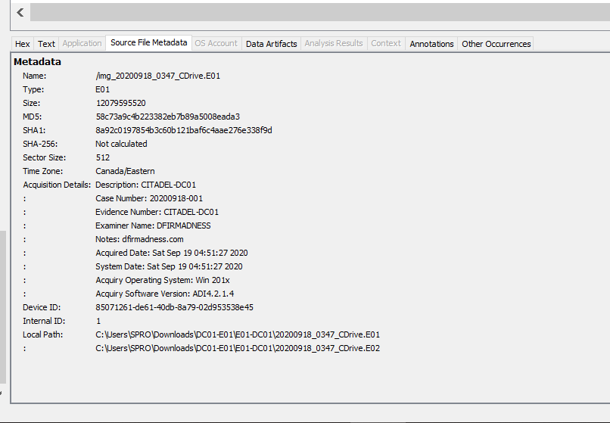

The Server IP Address is 10.42.85.115

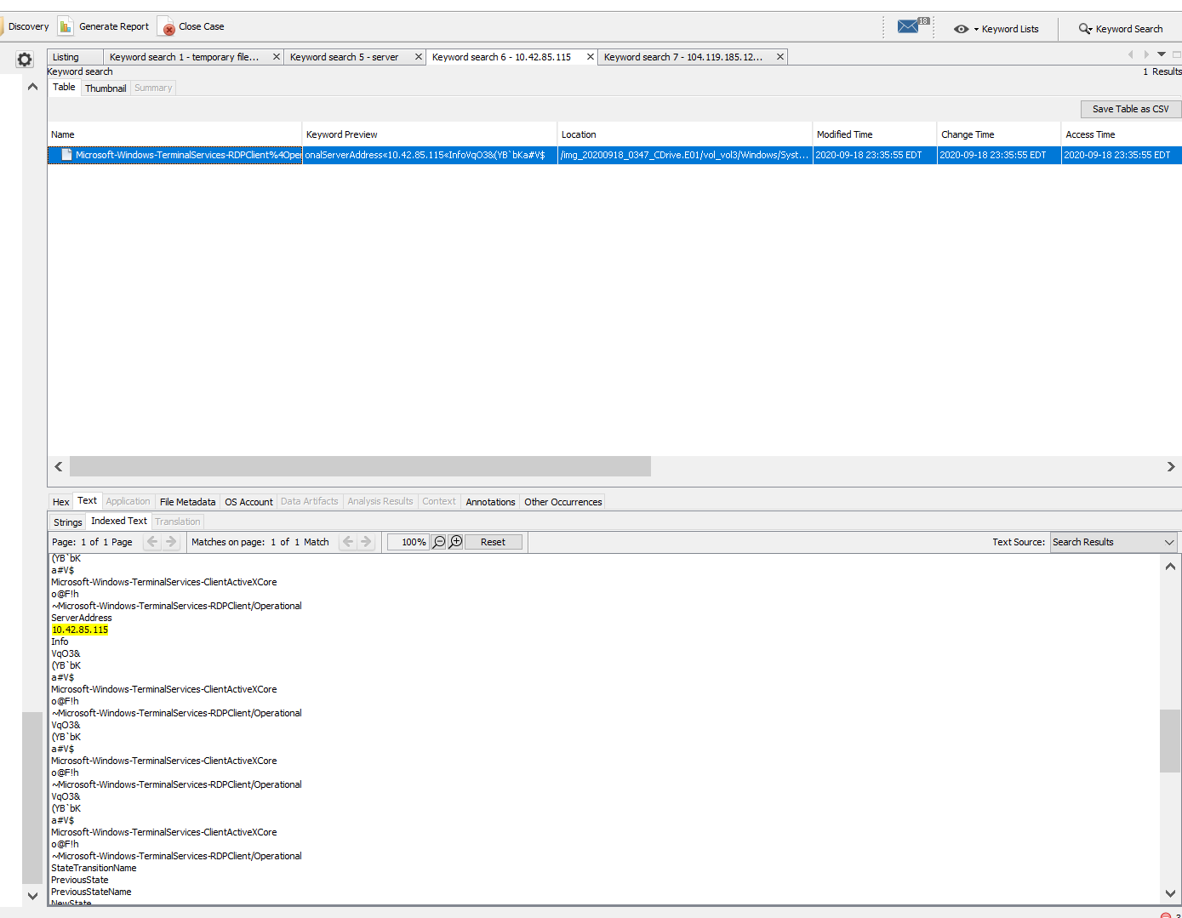

2

What’s the Operating System of the Desktop? Windows 2010

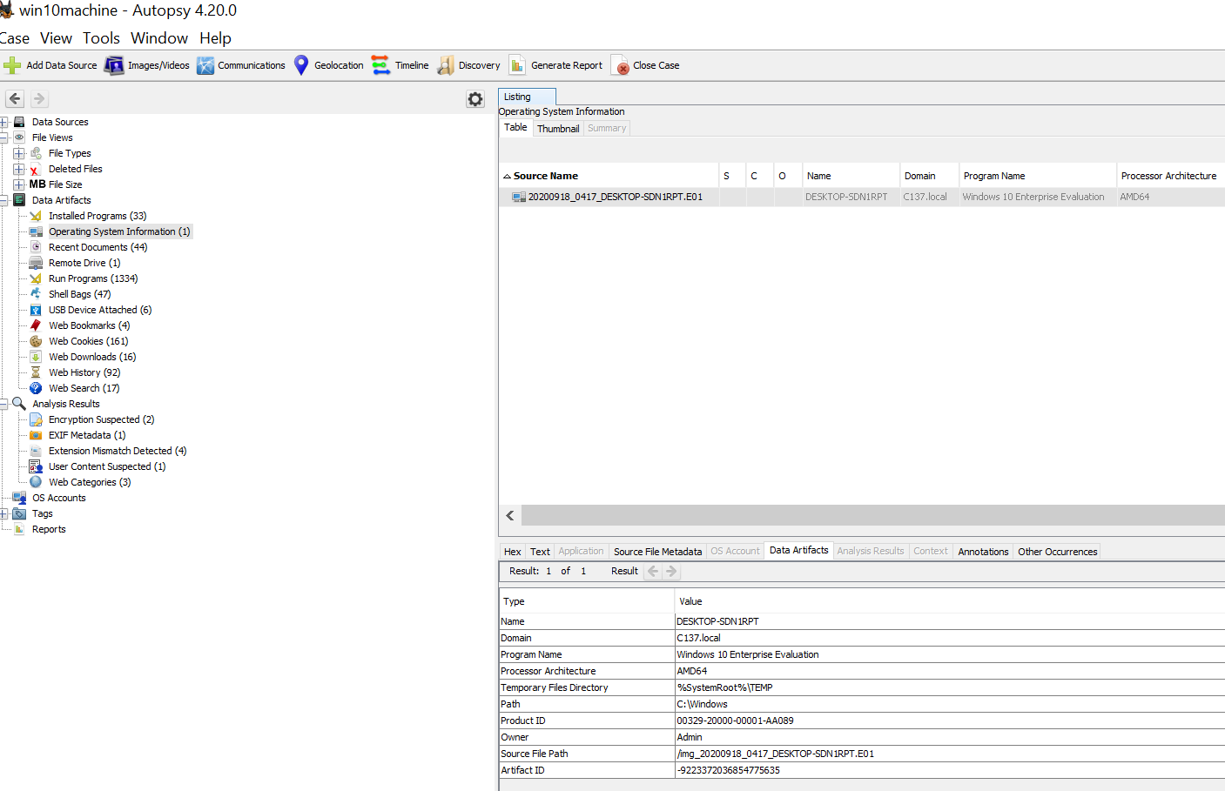

3

- Was there a breach? YES

Auto run Files: I did not find any anomalies within the auto run files however, I understand the concept and purpose of these files in the context of the Malware analysis. Even if the Malware was detected and the security team has patched the system removed the Malware it is imperative to check registries and auto run files to ensure that any changes made have noticed and mitigated. The threat actors can use these file to hold there persistence on a system and if not detected and the issue is not properly resolved the Malware can startup at a system reboot and relaunch or execute.

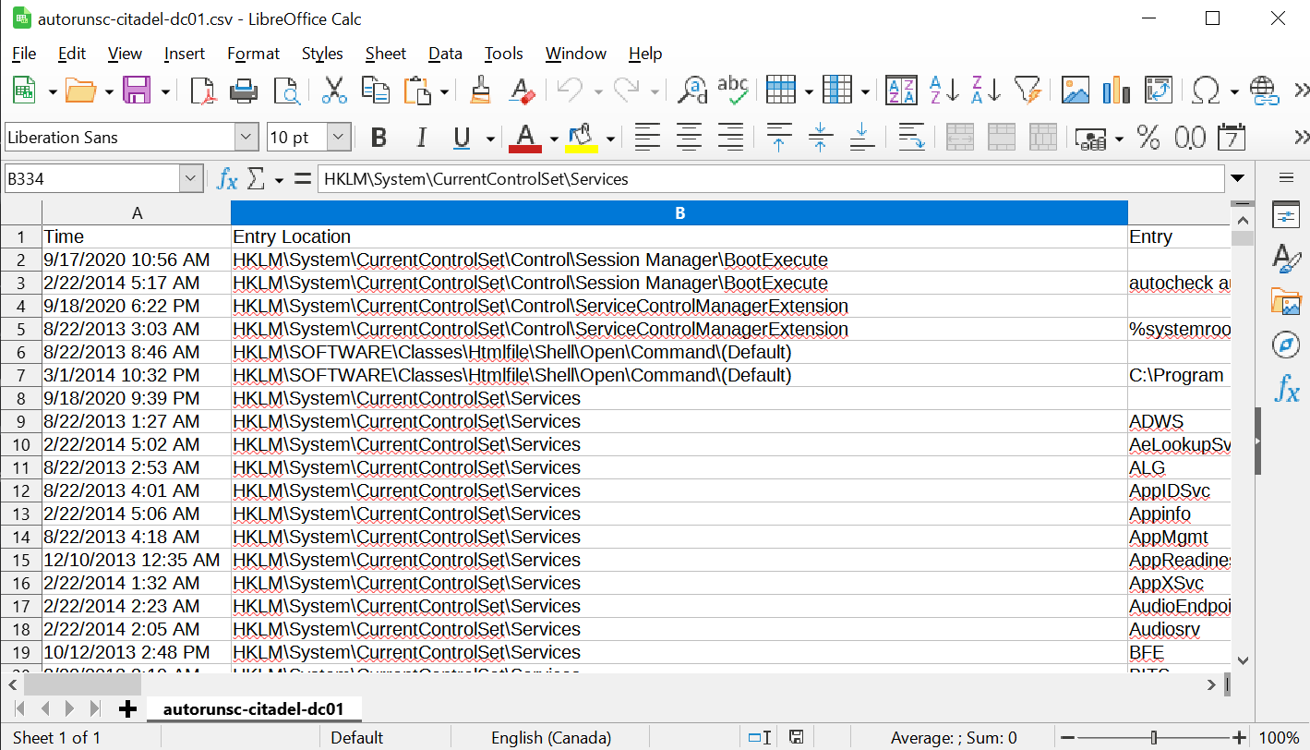

4

Using the find packet option in the edit tab, I was able to search for a .exe files contained in the packets. I then used the follow TCP stream to further analyze what was contained there.

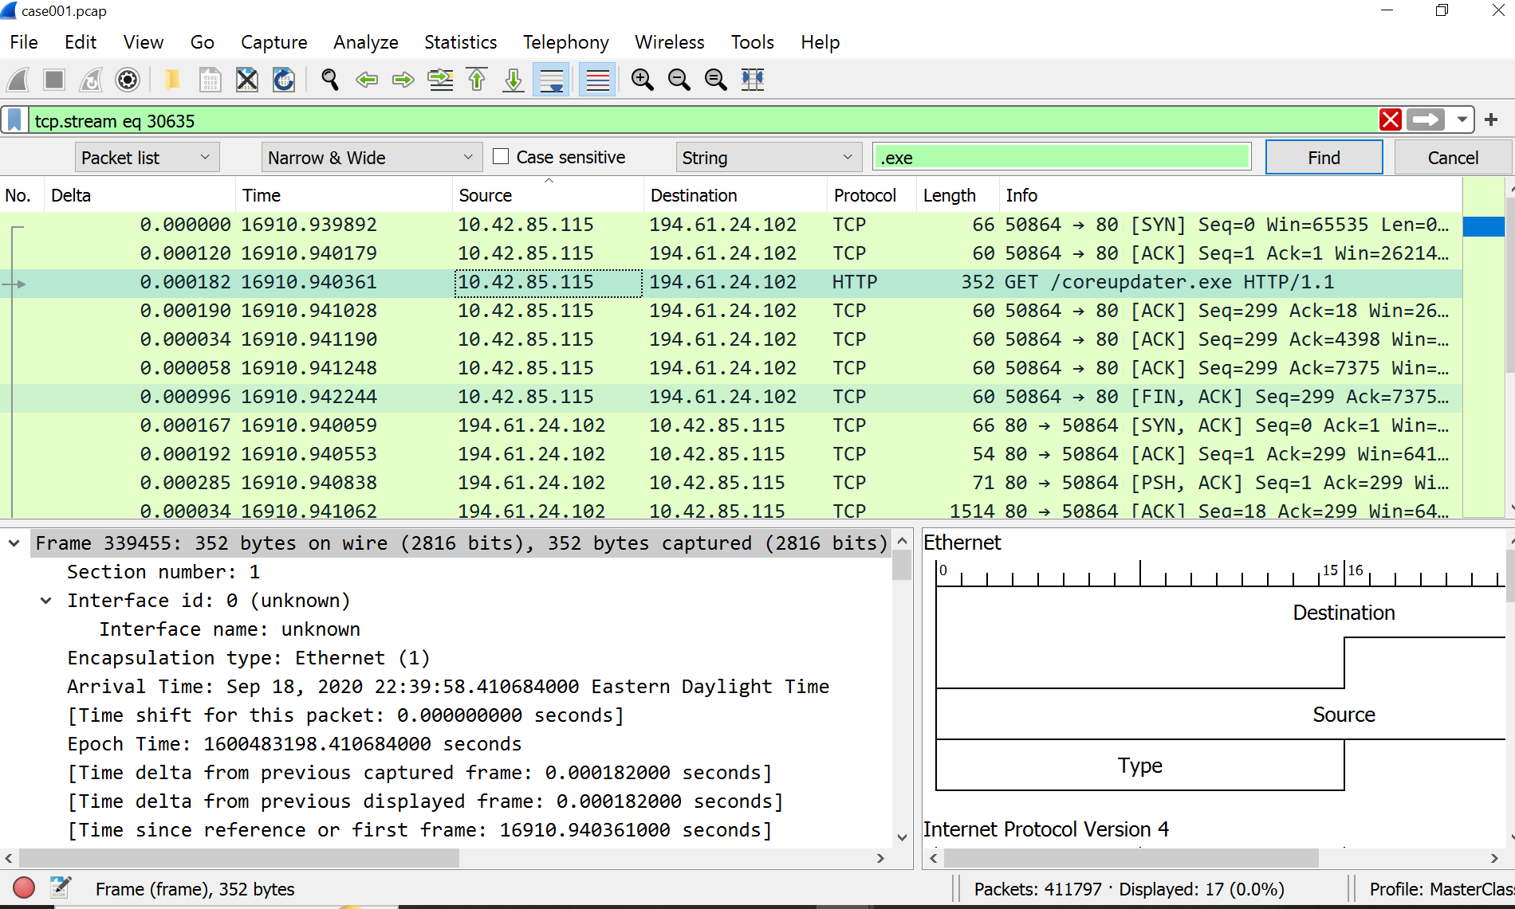

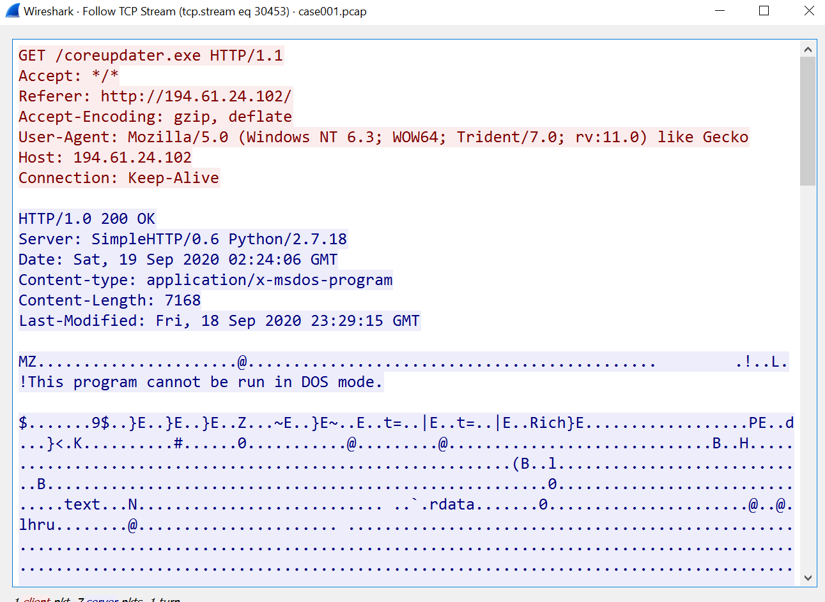

5
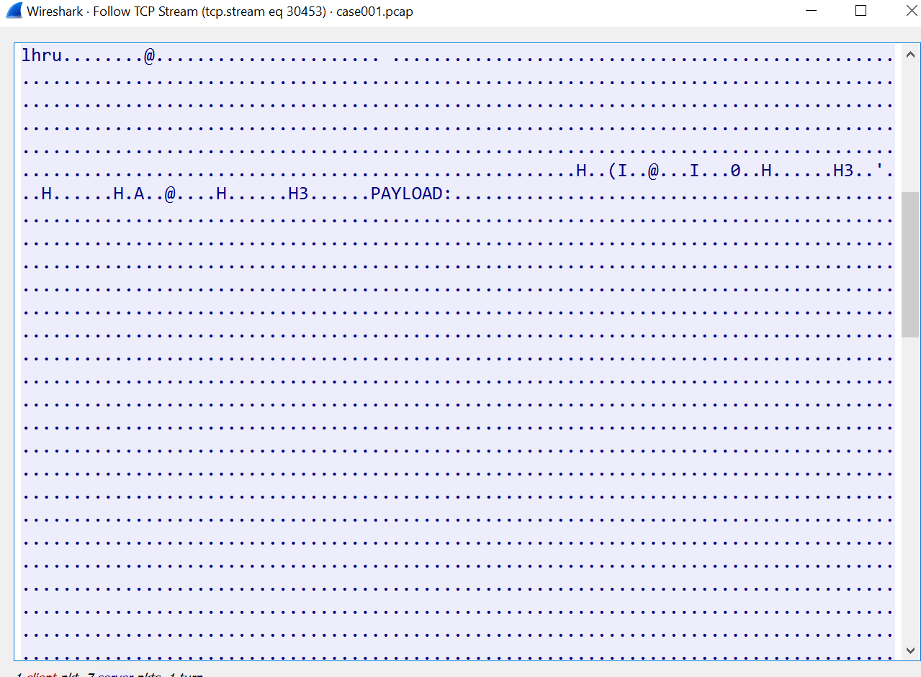

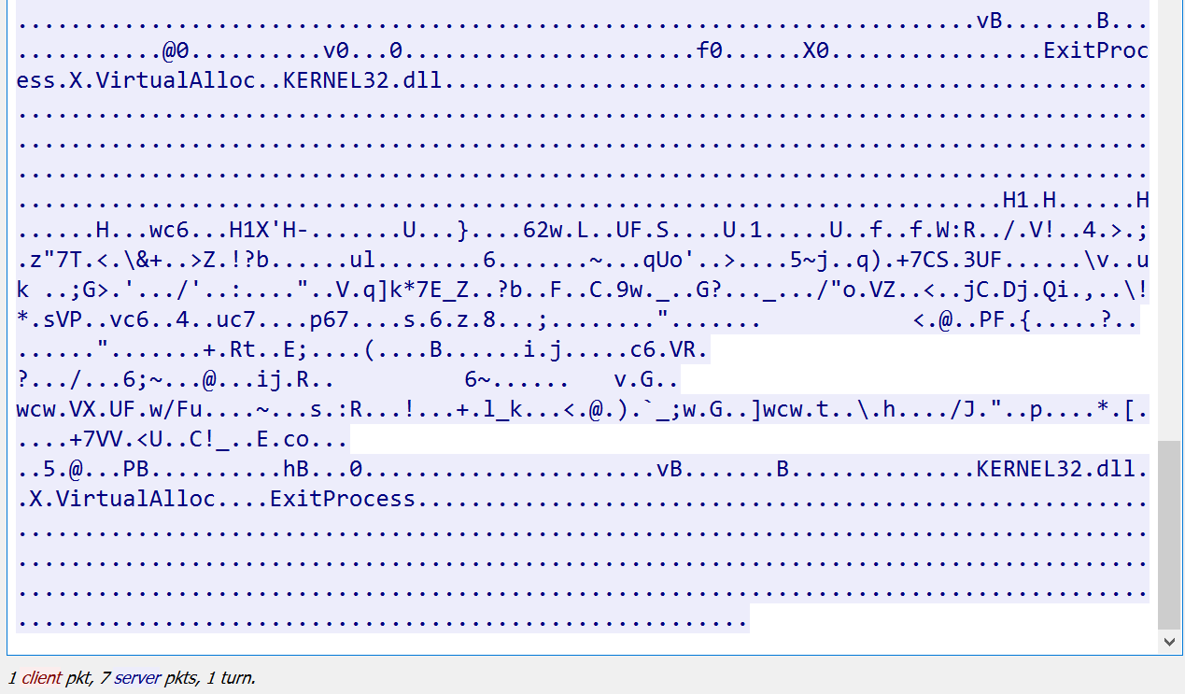

6
I have verified the malicious IP using the VIRUS TOTAL website tool.

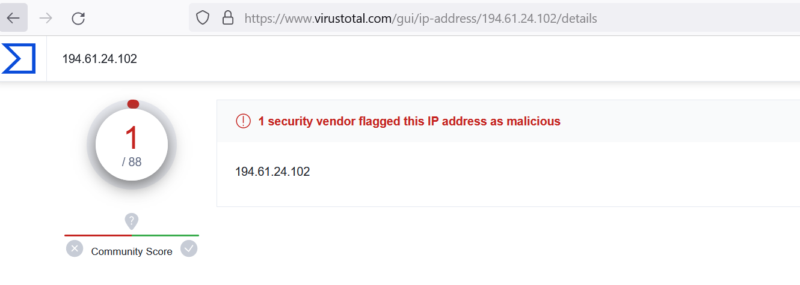

Using Autopsy to search for the file I found in the Wire Shark packet, I was able to export to VirusTotal and scan the .exe file . The results that verify the file was malicious.

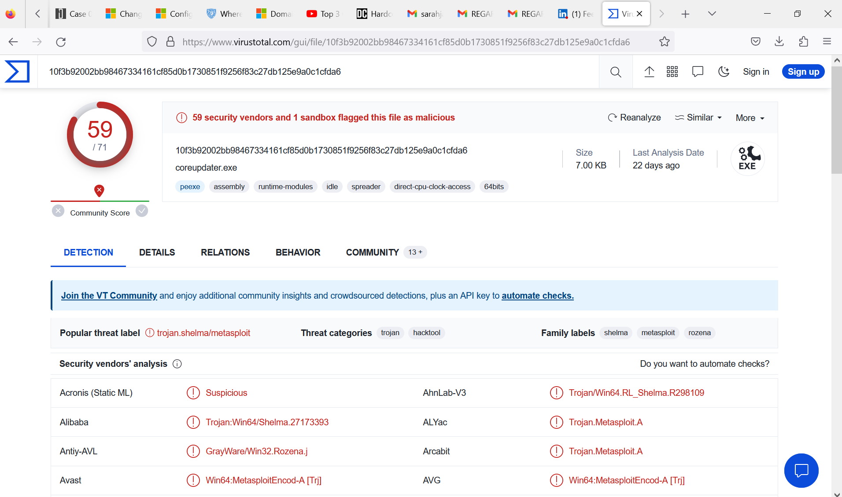

7

The Hash was verified from the original Image file. This was contributed by Lind Cheng.

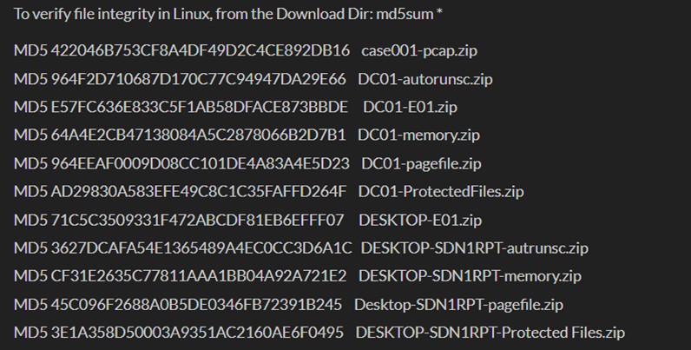

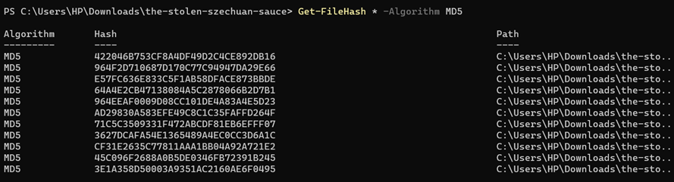

8

Secret file
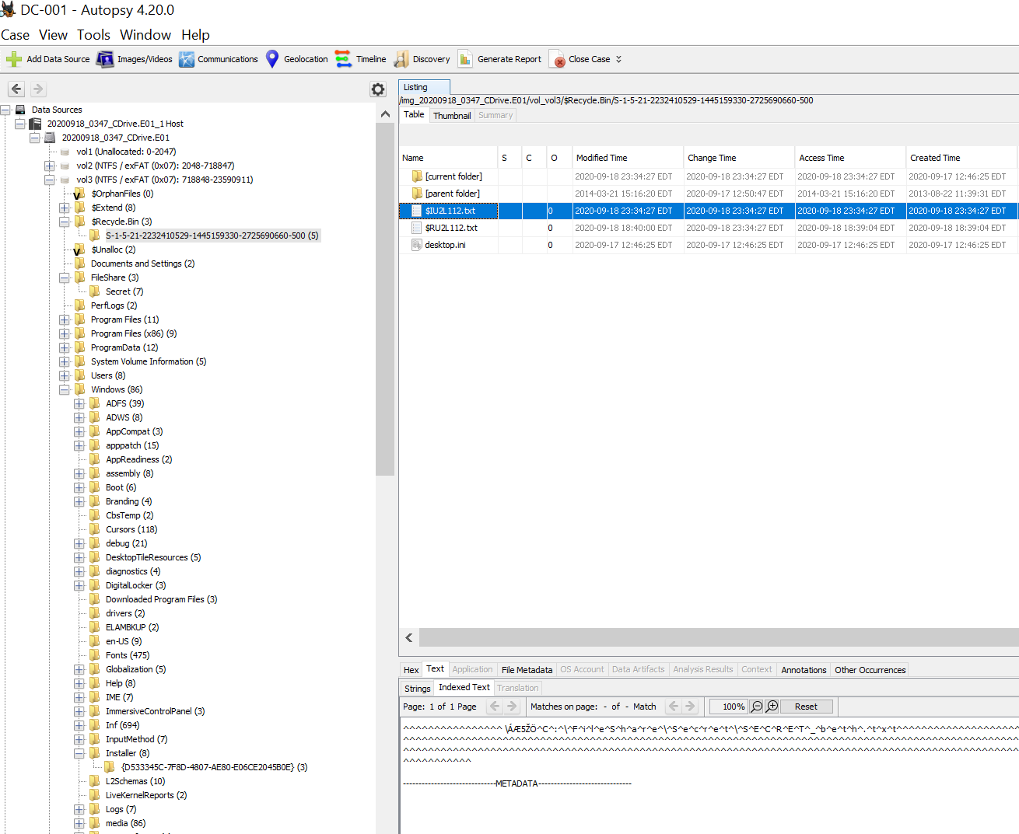

Conclusion
The main architecture improvement that should be made is installing a firewall and an Intrusion detection system. This could have helped with an attack being identified and stopped at the perimeter. Installing anti-virus software to detect any malicious files being installed on the system should be a standard and would have made a great difference in this case. Adding a jump-host login using multi factor authentication would force the verification of credentials for those trying to access the network remotely. Also, changing the port of the RDP protocol to a higher port could have made a difference to scan results of an attacker as most defaults scans search for know parameters like RDP on port 3389.

Routines updates of operating systems and applications is always recommended using the proper configuration settings for any remote and server connections. Encrypting data and sensitive information is always a good practice for securing data at rest. Monitoring traffic and and systems for registry changes are some proactive measures any organization can take to improve their security posture.
9

